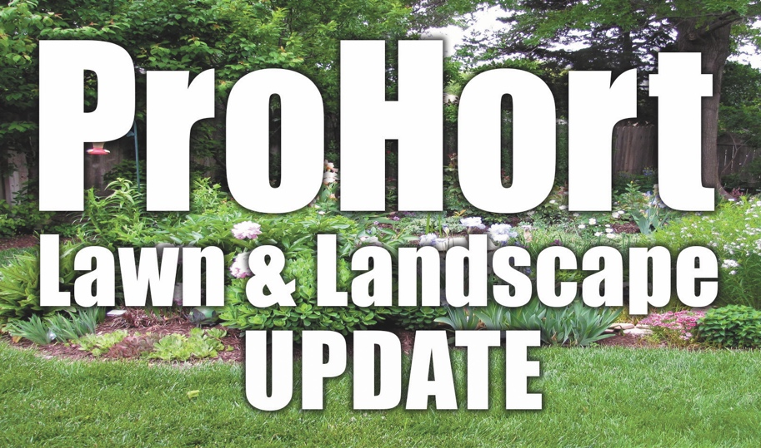

**Register by February 2nd**

Include cash or check payable to Lancaster County Extension.

Mail to:  
Nebraska Extension in   
Lancaster County  
444 Cherrycreek Road, Suite A  
Omaha, NE 68528

Or call (402) 441-7180 to pay by phone with credit card.

*Additional processing fee for debit/credit card payment.*

**Topics will focus on:**

* A Good Start to Structure: Pruning Young Trees
* Myth Busters: Debunking Common Horticulture Misinformation
* What Killed My Plant?
* In the Weeds about Weeds

*ISA and NAA CEU credits available*

**Register by February 2nd, 2022**

*Mail in this registration form with payment.*

**Cost is $20.00 (lunch on your own)**

**For More Information**

Contact Sarah Browning

(402) 441-7180

[Sarah.browning@unl.edu](mailto:Sarah.browning@unl.edu)

**Weather Cancellation***If Lincoln Public Schools close due to inclement weather the day of the program, this program will be cancelled and refunds provided to those preregistered.*

Employer/Business: ________________________________________________

Names(s): ________________________________________________________

Address: _________________________________________________________

City, State, Zip: ____________________________________________________

Phone: __________________________________________________________

Email: ___________________________________________________________

# Attending: ______ Fee (x $20.00 per person) Enclosed: _________________

Extension is a Division of the Institute of Agriculture and Natural Resources at the University of Nebraska- Lincoln cooperating with the Counties and the United States Department of Agriculture.

Nebraska Extension educational programs abide with the nondiscrimination policies of the University of Nebraska-Lincoln and the United States Department of Agriculture.

ProHort Update Registration Form

**Tuesday February 8th**

**8:30 a.m. – 4:15 p.m.**

Nebraska Extension in Lancaster County

444 Cherrycreek Road, Suite A

Lincoln, NE 68528

A workshop for nursery & green industry professionals, public works employees, landscape managers, arborists, tree board volunteers and cemetery & grounds keepers.