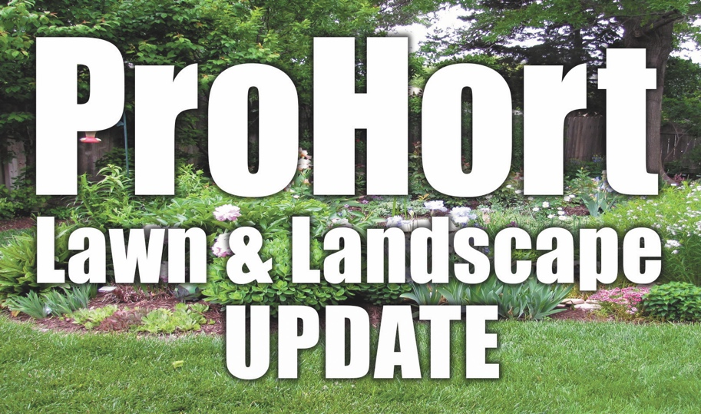

**Topics will focus on:**

* A Good Start to Structure: Pruning Young Trees
* Myth Busters: Debunking Common Horticulture Misinformation
* What Killed My Plant?
* In the Weeds about Weeds

*ISA and NAA CEU credits available*

**Register by March 11, 2022**

*Mail in this registration form with payment.*

**Cost is $45.00 (lunch included)**

*Meal not guaranteed for those registering after March 11, 2022*

**For More Information**

Contact: John Fech

(402) 444-7804

jfech1@unl.edu

**Weather Cancellation** *If Omaha Public Schools close due to inclement weather the day of the program, this program will be cancelled and refunds provided to those preregistered.*

Employer/Business: ________________________________________________

Names(s): ________________________________________________________

Address: _________________________________________________________

City, State, Zip: ____________________________________________________

Phone: __________________________________________________________

Email: ___________________________________________________________

# Attending: ______ Fee (x $45.00 ) Enclosed: _________________

**Register by March 11, 2022**

Include cash or check payable to University of Nebraska-Lincoln.

Mail to:

Nebraska Extension in

Douglas County

8015 W. Center Rd.

Omaha, NE 68124

Extension is a Division of the Institute of Agriculture and Natural Resources at the University of Nebraska- Lincoln cooperating with the Counties and the United States Department of Agriculture.

Nebraska Extension educational programs abide with the nondiscrimination policies of the University of Nebraska-Lincoln and the United States Department of Agriculture.

ProHort Update Registration Form

**Thursday March 17th**

**8:00 a.m. – 3:30 p.m.**

Douglas County Extension Office

8015 W. Center Rd.

Omaha, NE 68124

A workshop for nursery & green industry professionals, public works employees, landscape managers, arborists, tree board volunteers and cemetery & grounds keepers.