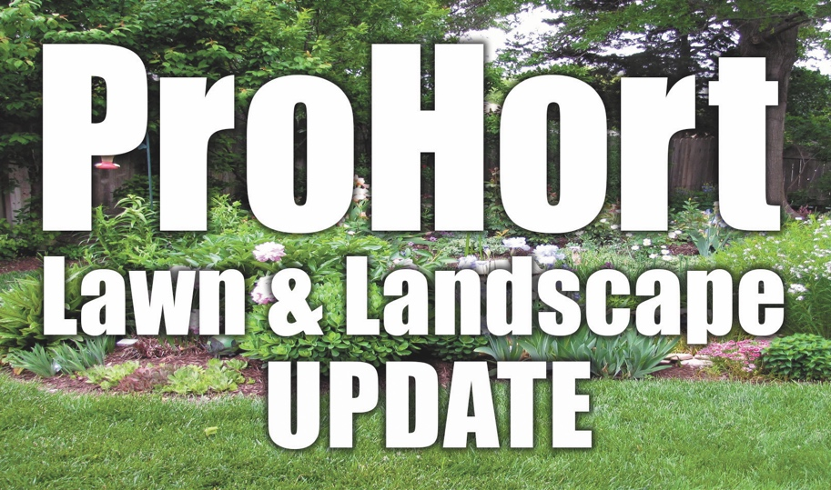

**Topics will focus on:**

* A Good Start to Structure: Pruning Young Trees
* Myth Busters: Debunking Common Horticulture Misinformation
* What Killed My Plant?
* In the Weeds about Weeds

*ISA and NAA CEU credits available*

**Register by February 22, 2022**

*Mail in this registration form with payment.*

**Cost is $10**

**For More Information**

Contact Elizabeth Exstrom

308-385-5088

[eexstrom2@unl.edu](mailto:eexstrom2@unl.edu)

**Weather Cancellation**If Central Community College in Grand Island or College Park closes due to inclement weather the day of the program, this program will be cancelled and refunds provided to those preregistered.

Employer/Business: ________________________________________________

Names(s): ________________________________________________________

Address: _________________________________________________________

City, State, Zip: ____________________________________________________

Phone: __________________________________________________________

Email: ___________________________________________________________

# Attending: ______ Fee (x $10.00) Enclosed: _________________

**Register by February 22, 2022**

Include cash or check payable to University of Nebraska Lincoln

Mail to:

Nebraska Extension in

Hall County

3180 W. Hwy 34

Grand Island NE 68801

Extension is a Division of the Institute of Agriculture and Natural Resources at the University of Nebraska- Lincoln cooperating with the Counties and the United States Department of Agriculture.

Nebraska Extension educational programs abide with the nondiscrimination policies of the University of Nebraska-Lincoln and the United States Department of Agriculture.

ProHort Update Registration Form

**March 2, 2022**

**8:30 am- 3:30 pm**

Nebraska Extension in Hall County Meeting Room

3180 W. Hwy 34

Grand Island NE 68801

A workshop for nursery & green industry professionals, public works employees, landscape managers, arborists, tree board volunteers and cemetery & grounds keepers.